# **Facebook Diagrams**

# UseCase Diagaram:

# Filter Posts Sequence Diagram:

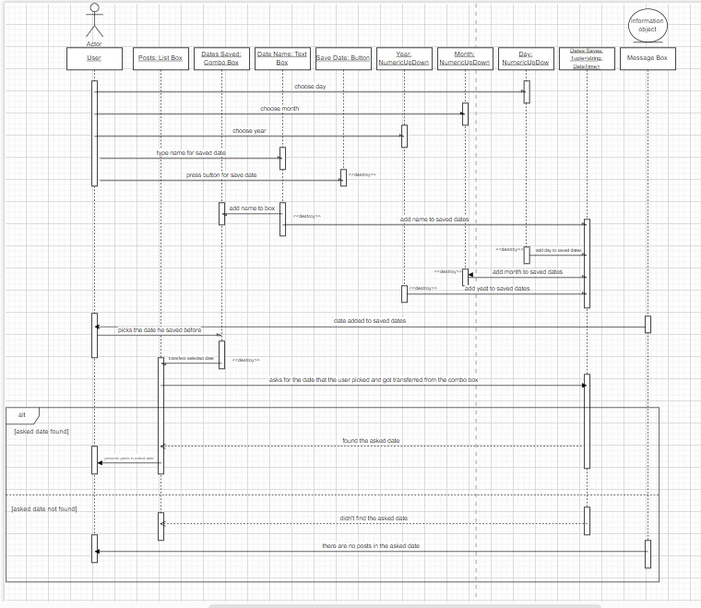

# Best Friend Competition Sequence Diagram:

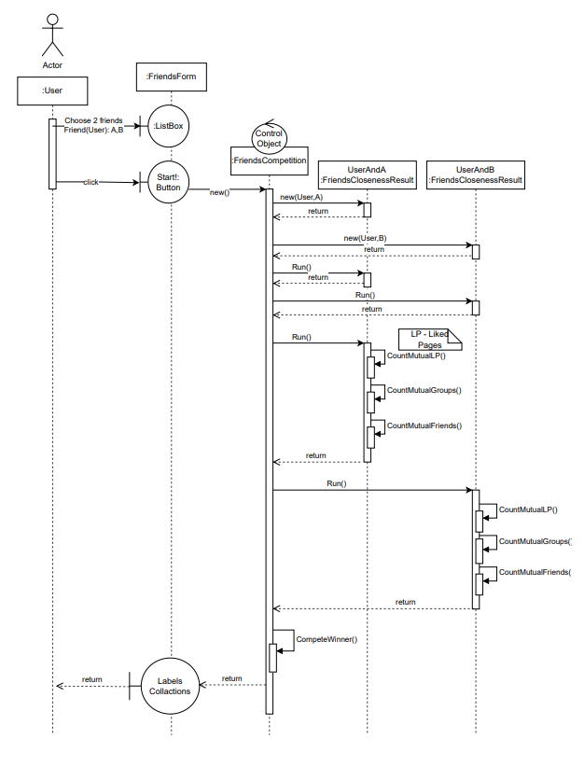

# Facebook Desktop Class Diagram:

